
TRIBHUVAN UNIVERSITY
INSTITUTE OF SCIENCE AND TECHNOLOGY
Central Department of Computer Science and Information Technology

DDoS attacks, its detection and preventive measures:
A study report

By:
Brihat Ratna Bajracharya
19/075

SUBMITTED TO THE CENTRAL DEPARTMENT OF COMPUTER SCIENCE AND INFORMATION TECHNOLOGY IN PARTIAL FULFILLMENT OF THE REQUIREMENT FOR THE MASTER’S DEGREE IN COMPUTER SCIENCE AND INFORMATION TECHNOLOGY

Central Department of Computer Science and Information Technology
Kirtipur, Kathmandu

December, 2019
TRIBHUVAN UNIVERSITY
INSTITUTE OF SCIENCE AND TECHNOLOGY
CENTRAL DEPARTMENT OF COMPUTER SCIENCE AND INFORMATION TECHNOLOGY

CERTIFICATE OF APPROVAL

The undersigned certify that they have read, and recommended to the Institute of Science and Technology for acceptance, a seminar report entitled “DDoS attacks, its detection and preventive measures: A study report” submitted by Brihat Ratna Bajracharya in partial fulfillment of the requirements for the Master’s degree in Computer Science and Information Technology

---------------------------------------
Mr. Jagdish Bhatta
Supervisor
Central Department of Computer Science and Information Technology

---------------------------------------------
Mr. Bikash Balami
Coordinator
Central Department of Computer Science and Information Technology

------------------------------------------------
Mr. Nawaraj Paudel
Head of Department
Central Department of Computer Science and Information Technology

DATE OF APPROVAL:
Table of Contents
CERTIFICATE OF APPROVAL ii
LIST OF ABBREVIATIONS iv
ACKNOWLEDGMENT vii
ABSTRACT viii
1. INTRODUCTION 1

1.1. Denial of Service (DoS) Attack 1

1.2. Distributed Denial of Service (DDoS) Attack 1

1.3. DDoS vs Flash Events 1
2. Detection of DDoS Attacks 2

2.1. Classification Based 2

2.2. Entropy based system 2

2.3. Regression Based Network Traffic Analysis 3

2.4. Using Artificial Neural Network 4
3. PREVENTING FUTURE DDOS ATTACKS 5

3.1. By maintaining the blacklist of source IP addresses 5

3.2. By simply dropping the detected attack packets. 5
4. PERFORMANCE OF DETECTION SYSTEM 6

4.1. Classification Based DDoS Detection 6

4.2. Performance of Entropy based system 7

4.3. Performance evaluation of Regression based approach 7

4.4. Performance evaluation of ANN based approach 8
5. DISCUSSION AND CONCLUSION 10
REFERENCES 11

LIST OF ABBREVIATIONS
ANN
DDoS
DoS
FBI
FSM
HTTP
IAT
ICMP
IP
LS-SVM
PNN
TCP
UDP
Artificial Neural Network
Distributed Denial of Service
Denial of Service
Federal Bureau of Investigation
Finite State Machine
Hyper Text Transfer Protocol
Inter Arrival Time
Internet Control Message Protocol
Internet Protocol
Least Square Support Vector Machine
Probabilistic Neural Network
Transmission Control Protocol
User Datagram Protocol

LIST OF FIGURES
Figure 1: DDoS Attack 1
Figure 2: Six fold cross-validation result 7
Figure 3: Malware Traffic Detection Result (Source: Divakaran et al.[ref diva]) 8

LIST OF TABLES
Table 1: Classification Performance Average (Single Source of Attack) 6
Table 2: Classification Performance Average (Multiple Sources of Attack) 6
Table 3: Comparison of ANN with other approaches 8
Table 4: Comparision between old and up-to-date dataset 9

ACKNOWLEDGMENT

I would like to express my indebted gratitude and sincere thanks my supervisor Mr. Jagdish Bhatta for his continuous support, guidance and supervision by which this seminar has been possible. I would also like to thank Central Department of Computer Science and Information Technology for arranging such a schedule for the academic course.
Every attempt has been made to most of the details in each and every aspects of the seminar in this documentation so that the reader can clearly understand about the seminar. We would be pleased to get the feedbacks on this report. Finally I would like to express our gratitude to my family, friends and well wishers for encouraging and supporting me.

ABSTRACT

Keywords: network security, regression, DDoS attack, flash event, classification

1. INTRODUCTION

1.1. Denial of Service (DoS) Attack
A DoS attack is a denial of service attack where a computer (or computers) is used to flood a server with TCP or UDP packets. In this attack, the service is put out of action as the packets sent overload the server’s resources and make the server unavailable to other devices and users throughout the network.

1.2. Distributed Denial of Service (DDoS) Attack
A DDoS attack is the most common type of DoS attack in which multiple systems target a single system with a DoS attack. The targeted network is bombarded with packets from multiple locations. DDoS attack is more complicated to recover. DDoS attacks are not only a widespread attack but also the second most common cybercrime attack to cause financial losses[aqeel shahi ref2] according to the United States Federal Bureau of Investigation (FBI) and since the attack is generated from multiple computers across distributed network, it becomes very hard to differentiate DDoS attack from the genuine traffic.
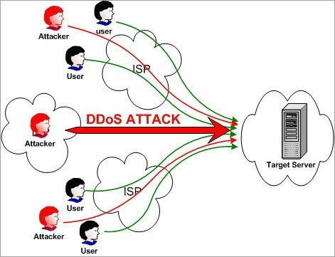Figure 1: DDoS Attack
DDoS attacks can be done in two different ways, direct and indirect. Direct attack target the victim’s machine in its weakness of the system while in indirect attack, attacks are performed on the elements associated with the victim’s machine.

1.3. DDoS vs Flash Events
DDoS attacks corresponds to large number of compromised systems flood requests to one or more servers in distributed environment while Flash events corresponds to large number of genuine traffic that occurs due to certain flash events. Flash events how ever resembles to that of DDoS traffic. The main difference between two is that the access intent in case of flash event is genuine and shows natural flow pattern.

2. Detection of DDoS Attacks
Many researchers have contributed their time in research of effectively detecting the DDoS traffic differentiating from genuine traffic. Researchers have dived into detection using various methodologies and techniques. This section briefly points out some of the detection techniques used for the detection of DDoS attacks and to correctly identify Flash events

2.1. Classification Based
[aqueel shahi] Sahi et al [ref ro aqueel paper] has proposed a new classifier system for the detection as well as prevention of DDoS TCP flood attacks in their paper. Their proposed system can identify these attacks regardless of the form of in which these attacks comes to the system. In this classification based system, the detection sub-system collects the incoming packet within a time frame, and then passed through the blacklist checker where the source IP of the packet is checked with the database of blacklist. If the source IP is matched in blacklist, it is directly sent to prevention for safety, If the packet passed the blacklist check, it is then passed through the classifier which decides whether the packet is normal or abnormat (from attacker). The normal packets are forwarded to the destination IP while the abnormal packets’ source IP is added to the blacklist thus simplifying future detection and the packet is sent to prevention sub-system

2.2. Entropy based system
Gera et al[gera ref] has proposed the system based on the anomaly of traffic patterns to differentiate between DDoS flood packets and genuine flash event traffic. This system is based on the fact that DDoS are artificial packets generated with the sole purpose of attacking the victim to flood its resources. So, this attack must have some kind of pattern. On the other hand, flash events pattern are more genuine and random and this randomness factor between two can be used for the detection of DDoS flood packets. Some of the parameters that can be used for this kind of detection are as follows:
a. Time Interval – before the DDoS attack, the network traffic is generally low. Suppose at time t1 the network shows less traffic and when the DDoS attack starts, the network traffic will spike up. Let this time be t2. In DDoS attack the network traffic abruptly increase while in case of flash event, the traffic will increase gradually (i.e. spread of a breaking news takes place in gradually increasing pace and end in same fashion)
b. Source entropy – It is the number of source IP addresses from which attack is launched. The traffic that comes from the same network is considered traffic cluster. A threshold entrophy is defined. Then while analysing the incoming traffic, if it is found that there are more source IPs but less traffic cluster, it is considered a flash event (i.e. more number of people pinging the news some few times). Similarly, if there are more source IPs and more traffic cluster, it is considered as a DDoS attack (spoofed) (i.e. attackers are using multiple IPs to attack the victim’s machine and these multiple source IPs are used multiple times). Finally if the source IP is same and the traffic cluster is same, it is also considered DDoS attack (i.e. attackers attacking the victim’s machine from the same IP; non-spoofed).

2.3. Regression Based Network Traffic Analysis
Divakaran et al. [divakaran paper ref] proposed a framework of gathering evidences to detect traffic sessions related to attacks and malicious activities. They applied regression models to detect fundamental anomalous patterns. Their framework include three stage approach for evidence gathering.
a. Modeling and analysing sessions to detect anomalous patterns – they defined a flow as a set of packets localized in time, and studied the inter-arrival time (IAT) of the flows in a session. Attack bots are likely to generate flows in fixed interval of time, i.e. the randomness in the arrival time is lesser than in normal scenario. The flow size is also another vital parameter to distinguish anomalous session with normal genuine session. Another parameter is the degree of the end host (number of distinct IP addresses that an end host communicates to). DoS attack can be detected using the modeling session using the degree of destination IP address.
b. Detecting scans and illegitimate TCP state sequences – The anomaly can also be detected using the TCP state sequence, the normal flow of a TCP packet can be modelled in a finite state machine with SYN, SYN+ACK, DATA and FIN packet. Any other flow that does not corresponds to this normal flow is considered illegitimate. From this FSM, we can say TCP flow is either legitimate or illegitimate is a binary decision depending on the FSM.

c. Evidence correlation and decision making – Spacial correlation is performed in this stage i.e. using IP addresses to correlate the anomalous pattern. One example is to look for the flows with the same IP addesss. Instead of spacial correlation, correlation in time can also be used but spacial correlation technique is more natural option as attacker may be passive for a while after succesful exploit.
After the framework stages are completed, the analysed data is processed to remove the outlier using a threshold for higher accuracy. The attack count if found nearly same will definitely raise suspicion. Also increasing count of attack packet with respect to time is also another type of anomaly detection technique. Regression models are then used to detect anomalous pattern. Authors have used linear regression to find the relationship between destination IP addresses with time. Quadratic regression is also used to detect anomalies using polynomial fit.

2.4. Using Artificial Neural Network
Saied et al. [Alan Saied ref] used supervised ANN (feed forward, error back propagation) approach on three different type of packets: TCP, UDP and ICMP. The ANN ICMP uses three input nodes (source_ip, icmp_sequence, and icmp_ip) with four hidden layer nodes to get the result in one output node. Similarly, ANN TCP uses five input nodes (source_ip, tcp_sequence, source_port, destination_port, and tcp_flags) and four hidden layer nodes to get outpur output in one output node. And in ANN UDP, four input layer nodes (source_port, destination_port, source_ip, and packet_length) are taken with three hidden layer to get result in one output layer node. The ANN is trained to get output in either 0 or 1 indicating whether the packet is normal or abnormal respectively.
The basic flow for ANN based supervised learning is as follows:
1. DDoS detectors are installed in different network, each detector registering the IP of neighboring detectors and communicate via encrypted messages and continuously monitors the number of passing packets
2. If the number of packets are greater than certain threshold, then there is suspicion of the attack. The packets are sorted and IP of the victim is identified. The ANN retrieves the required patterns and prepares for the ANN engine. The trained ANN engine takes the input and produces the output.\
3. The second step is repeated for three times and majority result is considered final out of the three outcomes.
This ANN engine needs to be trained regularly for detecting up-to-date DDoS attacks.

3. PREVENTING FUTURE DDOS ATTACKS
After the detection phase is completed, we are now required to prevent such attacks in the future which comes in prevention phase. Some of the researches that tried to implement detection also provided some kind of preventive measures for DDoS attacks. Some of those are briefly explained in this section.

3.1. By maintaining the blacklist of source IP addresses
The classification based proposed model by Sahi et al.[ref aqueel ref] has the prevention subsystem that first alerts the system administrator of the attacks. Then on the second step, the subsystem adds the attacking source address to the blacklist which is later used by detection subsystem. And after all these steps, the attacking packet is finally dropped so that it does not reach the destination (i.e. victim’s machine).
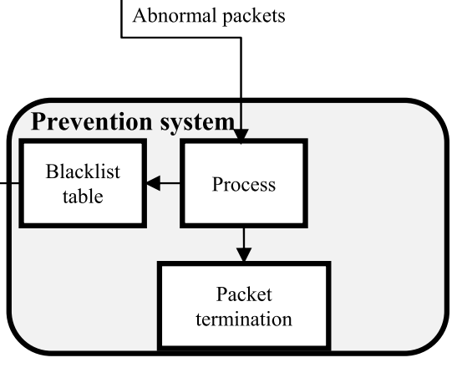Figure 2: Blacklisting of IPs from abnormal packet

3.2. By simply dropping the detected attack packets.
In the Artificial Neural Network based approach by Saied et al.[saied ref no], if the output of the ANN is 1, then the incoming packet is classified as attack packet. In this case, the defense component activates and drops the attack packet. They have implemented the defense mechanism as a separate plugin based on the Snort signature Intrusion Detection System Project[7] and integrated the plugin with Snort-AI [4]. Later the output from the detection system is coupled with destination IP to instruct iptables [8] to mitigate forged packets while allowing genuine traffic to pass through.

4. PERFORMANCE OF DETECTION SYSTEM
The efficiency and performance of the detection system described in section 2 is presented in this section. The performance related data is exteacted from the related researches and presented here as the information.

4.1. Classification Based DDoS Detection
Sahi et al. [] used four commonly used classification algorithms and validation is done using K-fold cross validation technique. The authors used LS-SVM, Naive Bayes, K-nearest and Multilayer perceptron for the classification and experimented for two different scenario. The first table is the Classification performance average for the algorithm under single source of attack while Table 2 is the classification performance average of the same algorithm for multiple source of attacks.
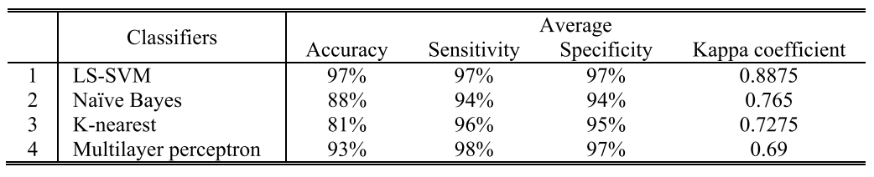Table 1: Classification Performance Average (Single Source of Attack)
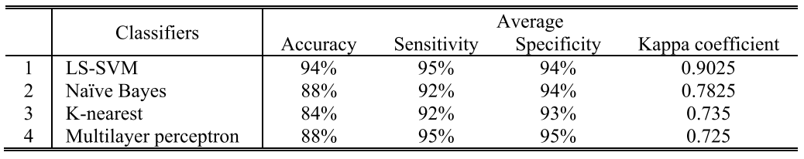Table 2: Classification Performance Average (Multiple Sources of Attack)
For the validation using K-fold, the dataset was divided into six equal sized chunks and five out of six chunks were used to train the model and remaining one chunk was used to test the model. This process wasa repeated for total of six times each with different set to test the model. And the result of six fold cross validation are almost the same which proved that the classification results are stable and accurate [sahi ref]. Also the proposed system showed 97 % accuracy in LS-SVM classification.

4.2. Performance of Entropy based system
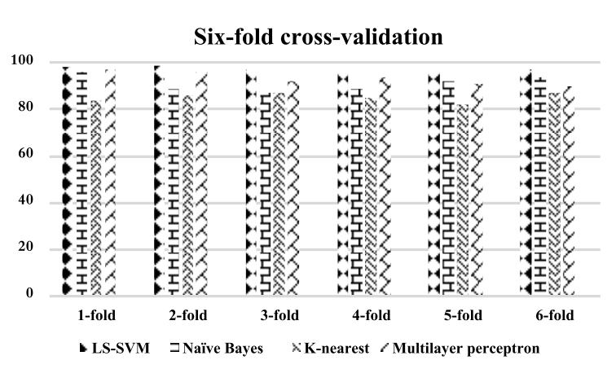Figure 3: Six fold cross-validation result
Gera et al.[Gera ref] used traffic cluster entropy as major part of detection metric which served two two purpose of detecting a DDoS attack and also differentiating DDoS traffic from flash event traffic. The author took two variables as design parameter and after multiple simulation the two parameters are found to be 3 and 4 for best detection rate, 5 and 6 for normal defense and higher values for false positive rate. This shows that when the tolerance value is taken lower values, it will ensure reduction of false negative and thus increase the detection rate. The author in the paper compared the result with the result of his previous work and found out that the current proposed system performed better in terms of detection rate.

4.3. Performance evaluation of Regression based approach
First component of the performance evaluation is the data. Divakaran et al.[diva ref] constructed data from multiple benign and malicious traffic because these are the kind of data involved in different types of attack including DDoS. And the author limit their scope of study to HTTP traffic only. There are two type of network traffic in their study. Normal traffic in which they used genuine network traffic captured from the co-authors and other set from publicly available source. Another type of network traffic is malware traffic which is obtained from Stratosphere IPS Project (2016) which include data traffic generated by botnets like Andromeda, Emotet, Geodo, Miuref, Sality, Yakes and Zues. Finally they normalize the regression output in range [0,1] and defined 0.7 as borderline between malicious and genuine traffic where higher than 0.7 denotes high score and lower than 0.7 are considered low scores. From their analysis, the detection result obtained is tabulated below.

4.4. Performance evaluation of ANN based approach
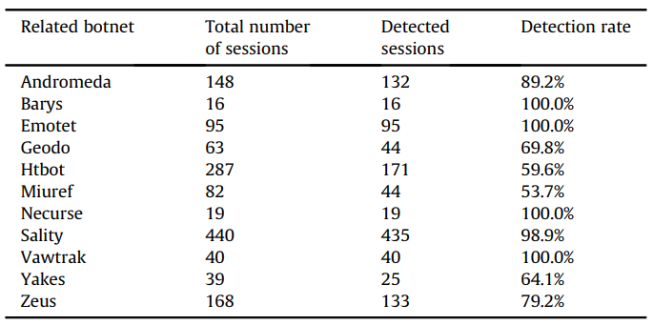Figure 4: Malware Traffic Detection Result (Source: Divakaran et al.[ref diva])
Saied et al. [] evaluated the ANN based solution on the basis of accuracy, precision, sensitivity (ability to identify positive result) and specificity (ability to identify negative result). They also compared their result with other approach like Snort[ai ref], PNN, Chi-square, and found that this approach performed better in all four basis. Also the comparision between old dataset and up-to-date dataset also affected the result in which up-to-date dataset solution produced an accuracy of 98 %. The performance is tabulated in table 3 and 4.
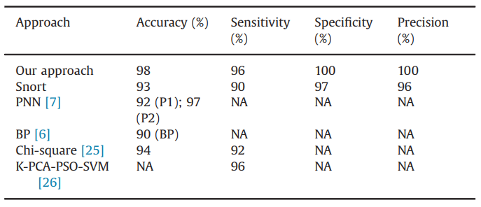Table 3: Comparison of ANN with other approaches

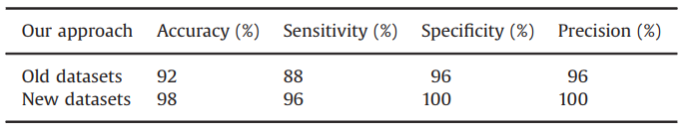Table 4: Comparision between old and up-to-date dataset

5. DISCUSSION AND CONCLUSION
The classification based proposed system by Sahi et al. has designed a good classifier using LS-SVM technique with promising accuracy but doesnot consider for spoofed IP addresses while the Entropy based system of [gera] considers both spoofed as well as non spoofed IP addresses to detect the DDoS attacks and also distunguish attack traffic from the genuine flash event. Although Gera et al. has considered their previous work and current proposed system and presented in favor of proposed system in terms of accuracy, the proposed system of [gera] is only tested in simulated environment and the result may deviate from the result obtained when testing in the real environment.
The evidence detection of [divakaran] using regression analysis only searched for the evidence of attack of different malware and does not provide concrete way around on how to prevent after the evidence has been obtained. Their framework has further scope of building an enhanced solution that not only gathers the evidence of the attack but also identify and classify the attack based on their profile (signature)
Finally the ANN based approach has few limitation as listed by the author themselves which all of the described system lacked. It is that if the attack packet’s protocol headers are encrypted, then there is no any possible way to analyse the encrypted information from the headers. We require source IP, packet length, source port, destination IP, destination port, protocols used etc to analyse the packet for anomaly.
Another thing is that attacker is using newer and newer techniques of attack so we need to be up-to-date with our system of detecting and preventing such attack. For this the ANN based approach needs constant periodic training of the models so as to cover all the available attack techniques and provide maximum result for each future attacks.
Among the limitations described above, the limitation due to encrypted packet headers can be most challenging topic for future researches.

REFERENCES
- A. Sahi, D. Lal, Y. Li, and M. Diykh, “An Efficient DDoS TCP Flood Attack Detection and Prevention System in a Cloud Environment”, in IEEE Access, vol. 5, pp. 6036-6048, 2017.
- A. Saied, R. E. Overhill, T. Radzik, “Detection of known and unknown DDoS attacks using Artificial Neural Networks”, in Neurocomputing 172, pp. 385-393, 2016.
- B. Cashell, W. D. Jackson, M. Jickling, and B. Webel, The Economic Impact of Cyber-Attacks, document CRS RL32331, Congressional Research Service Documents, Washington, DC, USA, 2004.
- C. Bedon, A. Saied, Snort-AI (Version 2.4.3), “Open Source Project”, 2009. Available from: http://snort-ai.sourceforge.net/index.php/
- D. M. Divakaran, K. W. Fok, I. Nevat, and V. L. L. Thing, “Evidence gathering for network security and forensics”, in Digital Investigation 20, pp. S56-S65, 2017.
- J. Gera, and B. P. Battula, “Detection of spoofed and non-spoofed DDoS attacks and discriminating them from flash crowds”, in EURASIP Journal on Information Security, doi:10.1186/s13635-018-0079-6, 2018.
- M. Roesch, Snort (Version 2.9), “Open Source Project”, 1998. Available from: http://www.snort.org/.
- R. Russell, Iptables (Version 1.4.21), “Open Source Project”, 1998. Available from: http://ipset.netfilter,org/iptables.man.html/.

